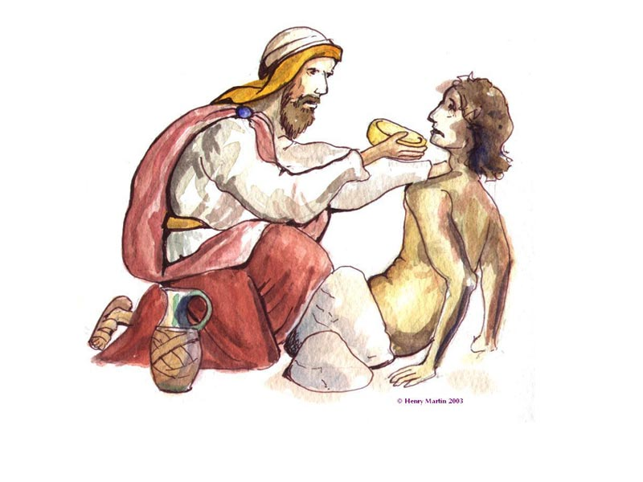


Your mission (should you care to accept it) is to retell the parable of the ‘Good Samaritan’ as if you were the beaten Jew!!!
In order to do this, you must explain EXACTLY what happened on that special day.

You must include all the facts below…

- Set the scene - where were you going? What was the road like? What did you have on you?
- What happened to you along the way?
- Who passed you by? Explain why they should have helped you?
- who finally came to your rescue? What was so strange about that?
- How did this stranger’s help impact on your life?
- Have your feelings toward Samaritans changed? Why? What have you learnt from your experience?

Produce a colourful, eye catching article for a local newspaper
Or a glossy magazine – share your joy with the World that somebody
came to your rescue!

GOOD LUCK!!!!!



